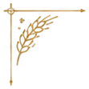
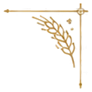
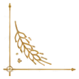
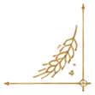

The Sacrament of Holy Matrimony
◆
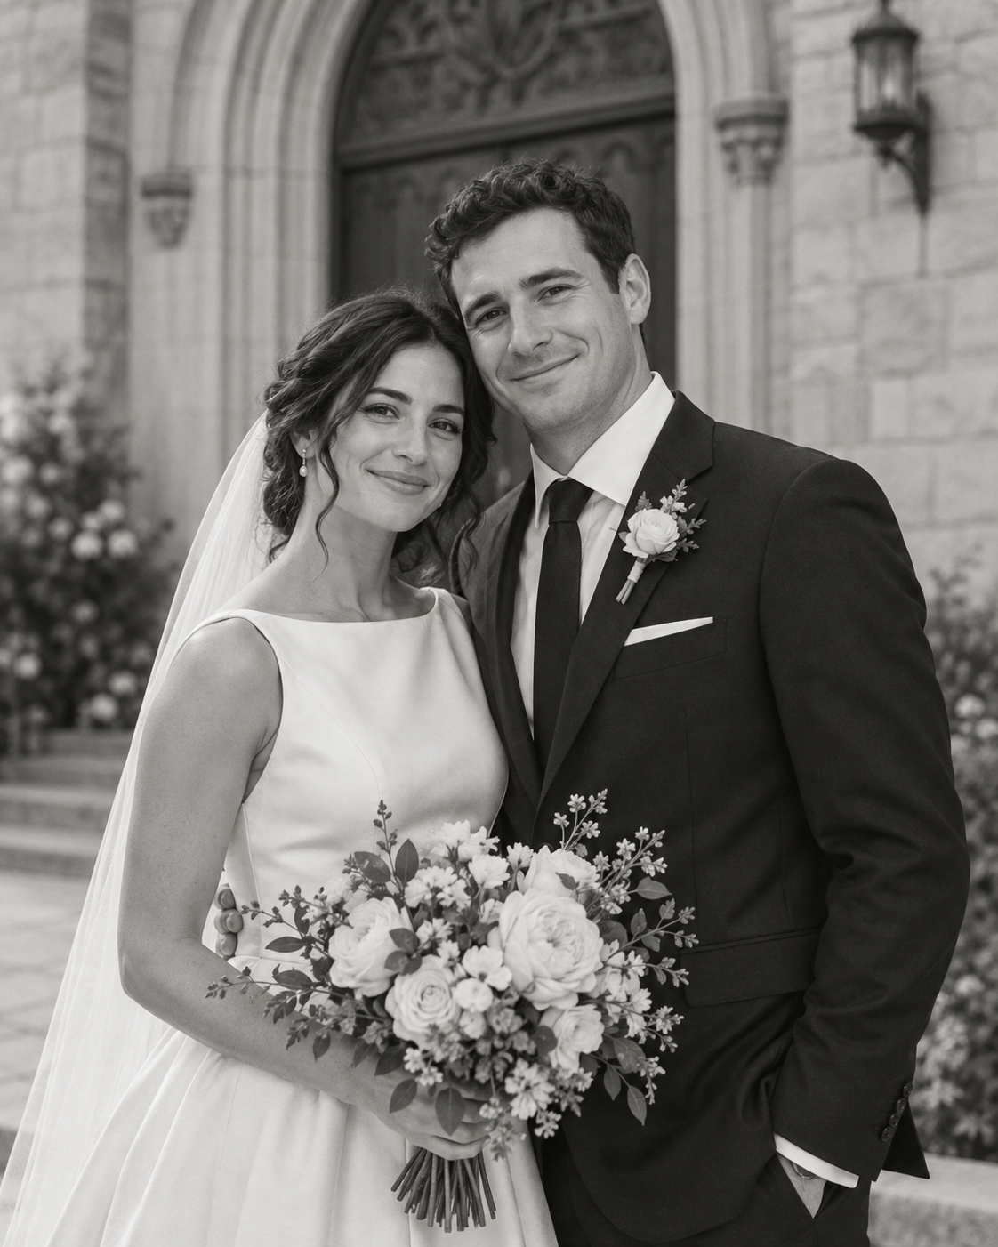
Katherine Rose Hartley
&
Daniel Joseph Corrigan
◆
Saturday, June 20, 2026
St. Michael the Archangel Catholic Church
Rev. Thomas J. Callahan, Celebrant

INTRODUCTORY RITES
Entrance Hymn
Canon in D
Johann Pachelbel
Greeting
The celebrant greets the assembly.
Collect
Let us pray...
LITURGY OF THE WORD
First Reading
Genesis 2:18-24
Yahweh God said, “It is not good for the man to be alone. I will make him a helper comparable to him.”
Out of the ground Yahweh God formed every animal of the field, and every bird of the sky, and brought them to the man to see what he would call them. Whatever the man called every living creature became its name.
The man gave names to all livestock, and to the birds of the sky, and to every animal of the field; but for man there was not found a helper comparable to him.
Yahweh God caused the man to fall into a deep sleep. As the man slept, he took one of his ribs, and closed up the flesh in its place.
Yahweh God made a woman from the rib which he had taken from the man, and brought her to the man.
The man said, “This is now bone of my bones, and flesh of my flesh. She will be called ‘woman,’ because she was taken out of Man.”
Therefore a man will leave his father and his mother, and will join with his wife, and they will be one flesh.
Responsorial Psalm
℟ Blessed is everyone who fears Yahweh,
Blessed is everyone who fears Yahweh,
who walks in his ways.
For you will eat the labor of your hands.
You will be happy, and it will be well with you.
Your wife will be as a fruitful vine,
in the innermost parts of your house;
your children like olive plants,
around your table.
Behold, thus is the man blessed who fears Yahweh.
May Yahweh bless you out of Zion,
and may you see the good of Jerusalem all the days of your life.
Second Reading
1 John 4:7-12
Beloved, let us love one another, for love is of God; and everyone who loves has been born of God, and knows God.
He who doesn’t love doesn’t know God, for God is love.
By this God’s love was revealed in us, that God has sent his one and only Son into the world that we might live through him.
In this is love, not that we loved God, but that he loved us, and sent his Son as the atoning sacrifice for our sins.
Beloved, if God loved us in this way, we also ought to love one another.
No one has seen God at any time. If we love one another, God remains in us, and his love has been perfected in us.

Gospel
John 15:9-12
Even as the Father has loved me, I also have loved you. Remain in my love.
If you keep my commandments, you will remain in my love; even as I have kept my Father’s commandments, and remain in his love.
I have spoken these things to you, that my joy may remain in you, and that your joy may be made full.
“This is my commandment, that you love one another, even as I have loved you.
RITE OF MARRIAGE
Homily
The celebrant speaks to the couple about the sacrament of marriage.
Declaration of Consent
The celebrant questions the bride and groom about their freedom to marry, their faithfulness, and their acceptance of children.
Exchange of Vows
The bride and groom exchange their marriage vows.
Blessing and Exchange of Rings
The celebrant blesses the rings and the couple exchanges them.
LITURGY OF THE EUCHARIST
Offertory Hymn
Ave Maria
Franz Schubert
Holy, Holy, Holy
Holy, Holy, Holy Lord God of hosts.
Heaven and earth are full of your glory.
Hosanna in the highest.
Blessed is he who comes in the name of the Lord.
Hosanna in the highest.
Nuptial Blessing
The celebrant invokes God's blessing upon the newly married couple.
Lamb of God
Lamb of God, you take away the sins of the world,
have mercy on us.
Lamb of God, you take away the sins of the world,
have mercy on us.
Lamb of God, you take away the sins of the world,
grant us peace.
Communion Hymn
Panis Angelicus
César Franck
Recessional Hymn
Ode to Joy
Ludwig van Beethoven

The Wedding Party
Maid of Honor — Sarah Whitfield
Best Man — James Corrigan
Bridesmaids — Anna Lee · Grace Kim
Groomsmen — Mark Tran · Luke Bennett
Readers — Emily Hartley · Peter Novak
With Gratitude
To our parents, family, and friends: thank you for surrounding us with your love and prayers today. We are blessed beyond measure to begin our life together in the presence of God and all of you.

St. Michael the Archangel Catholic Church
1450 Cathedral Avenue · Sacramento, California
(916) 555-0142
stmichael.example
Pastor: Rev. Thomas J. Callahan

Scripture texts from the World English Bible (public domain), unless a licensed translation was supplied.

