




Mass of Christian Burial
◆
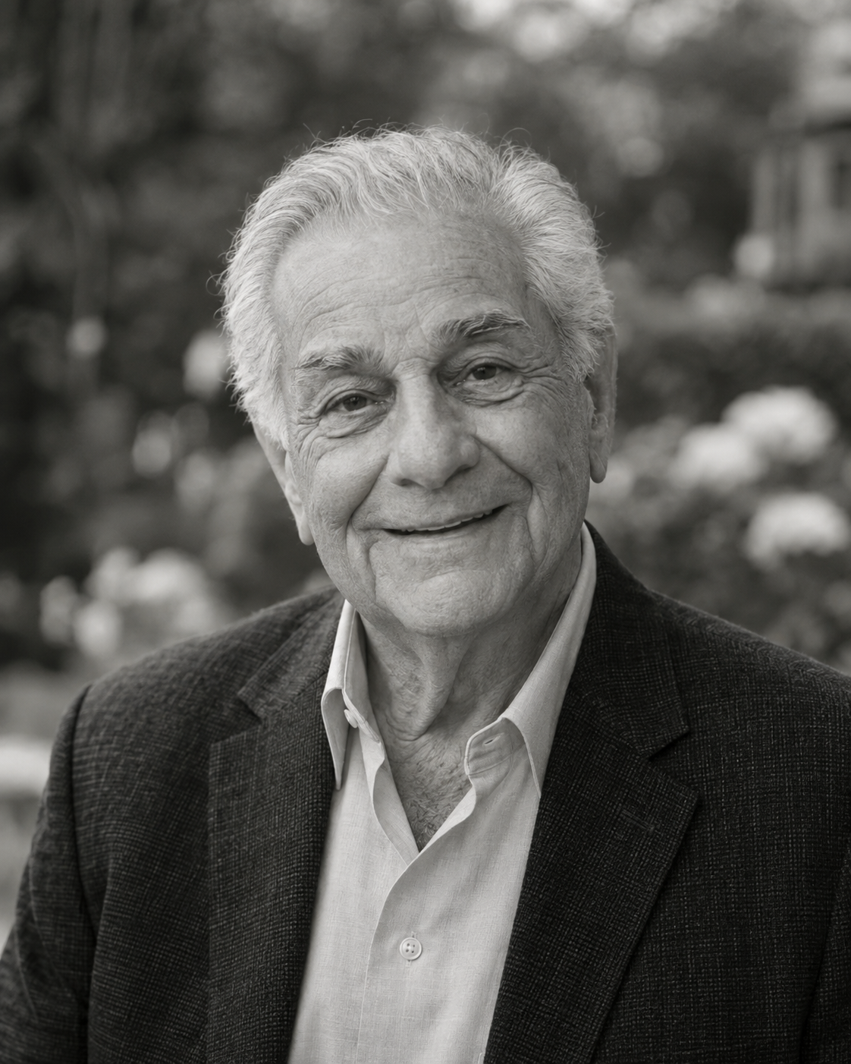
Robert James Rossi
March 12, 1938 – July 4, 2026
Beloved husband, father, and grandfather
◆
St. Michael the Archangel Catholic Church
Rev. Thomas J. Callahan, Celebrant

INTRODUCTORY RITES
Entrance Hymn
Be Not Afraid
Greeting
The celebrant greets the assembly and sprinkles the casket with holy water.
Collect
Let us pray...

LITURGY OF THE WORD
First Reading
Isaiah 25:6a, 7-9
In this mountain, Yahweh of Armies will make all peoples a feast of choice meat, a feast of choice wines, of choice meat full of marrow, of well refined choice wines.
He will destroy in this mountain the surface of the covering that covers all peoples, and the veil that is spread over all nations.
He has swallowed up death forever! The Lord Yahweh will wipe away tears from off all faces. He will take the reproach of his people away from off all the earth, for Yahweh has spoken it.
It shall be said in that day, “Behold, this is our God! We have waited for him, and he will save us! This is Yahweh! We have waited for him. We will be glad and rejoice in his salvation!”
Responsorial Psalm
℟ Yahweh is my shepherd:
Yahweh is my shepherd:
I shall lack nothing.
He makes me lie down in green pastures.
He leads me beside still waters.
He restores my soul.
He guides me in the paths of righteousness for his name’s sake.
Even though I walk through the valley of the shadow of death,
I will fear no evil, for you are with me.
Your rod and your staff,
they comfort me.
You prepare a table before me
in the presence of my enemies.
You anoint my head with oil.
My cup runs over.
Surely goodness and loving kindness shall follow me all the days of my life,
and I will dwell in Yahweh’s house forever.
Second Reading
1 John 3:1-2
See how great a love the Father has given to us, that we should be called children of God! For this cause the world doesn’t know us, because it didn’t know him.
Beloved, now we are children of God, and it is not yet revealed what we will be. But we know that, when he is revealed, we will be like him; for we will see him just as he is.

Gospel
John 6:37-40
All those whom the Father gives me will come to me. He who comes to me I will in no way throw out.
For I have come down from heaven, not to do my own will, but the will of him who sent me.
This is the will of my Father who sent me, that of all he has given to me I should lose nothing, but should raise him up at the last day.
This is the will of the one who sent me, that everyone who sees the Son, and believes in him, should have eternal life; and I will raise him up at the last day.”
FUNERAL RITES
Homily
The celebrant reflects on the life of the deceased and the hope of the resurrection.
Universal Prayer
The assembly joins in prayer for the deceased, the bereaved, and all the faithful departed.
LITURGY OF THE EUCHARIST
Offertory Hymn
How Great Thou Art
Holy, Holy, Holy
Holy, Holy, Holy Lord God of hosts.
Heaven and earth are full of your glory.
Hosanna in the highest.
Blessed is he who comes in the name of the Lord.
Hosanna in the highest.
Lamb of God
Lamb of God, you take away the sins of the world,
have mercy on us.
Lamb of God, you take away the sins of the world,
have mercy on us.
Lamb of God, you take away the sins of the world,
grant us peace.
Communion Hymn
On Eagle’s Wings
Final Commendation
The celebrant leads the final commendation and farewell.
Recessional Hymn
Amazing Grace

In Loving Service
Celebrant — Rev. Thomas J. Callahan
Pallbearers — John, Mark & Paul Rossi · Peter Deluca
First Reading — Maria Rossi-Deluca
Eulogy — Anthony Rossi
Music — St. Michael Parish Choir
Acknowledgment
The family of Robert Rossi extends heartfelt gratitude to Rev. Callahan, the parish staff, and the choir, and to each of you for the prayers and kindness shown during his illness and for joining us today to commend him to the Lord.

St. Michael the Archangel Catholic Church
1450 Cathedral Avenue · Sacramento, California
(916) 555-0142
stmichael.example
Pastor: Rev. Thomas J. Callahan

Scripture texts from the World English Bible (public domain), unless a licensed translation was supplied.

